Minecraft Edu

Starting Minecraft Edu (Student or Teacher)
Use the search bar to find Minecraft Edu
Click on it to start
Sign in with your Roanoke County Username (whole mail address) and Password
Hit Play

Find a World

Choose to Create a New World
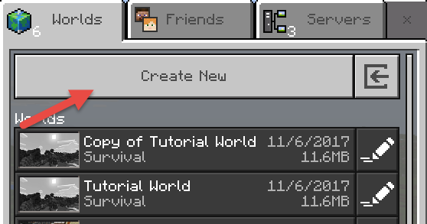

OR

Open an existing world
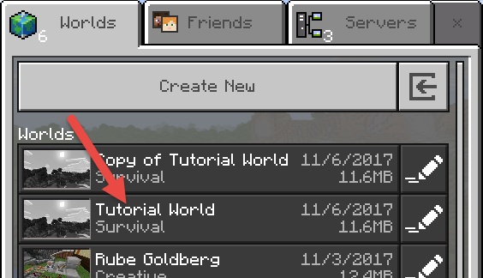
OR

Join a Game by Adding a Server
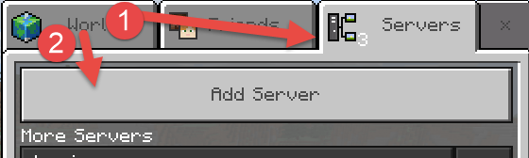
To join a game, have the person share their IP address.

Click on server > Add New Server
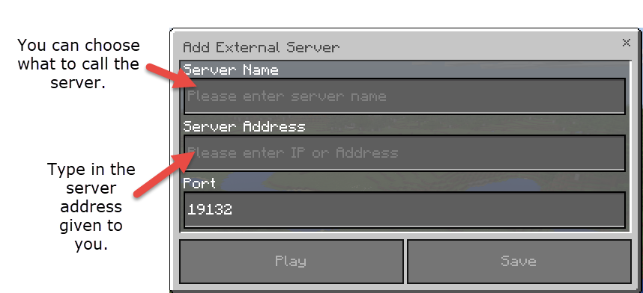
Then press Play to join their game.
Once you have added a server, it will be easy to find on that computer.

Moving Around Minecraft

Default Keyboard Controls
W |  | Move forward.
A |  | Move left.
S |  | Move backward.
D |  | Move right.
SPACE |  | When walking, spacebar will allow you to jump.  Pressing spacebar and W at the same time will allow you to move up the block in front of you. This is great for moving up staircases.  When swimming, spacebar will also bring you to the surface. This is important in Survival so you can breathe (you can’t hold your breath forever).  When in creative mode, pressing spacebar twice in a row will let you fly. Pressing it once more will let you levitate upwards. Pressing it twice again will drop you back to the ground. This is handy when you are trying to get somewhere quickly.
SHIFT |  | When on the ground, you will crouch down and sneak. When in the air (creative mode), you will fly downwards.
CONTROL |  | Sprint

Default Mouse Controls
Button 1  Left Click | Attack/Destroy
Button 2  Right Click | Use item/place block
Scroll Wheel | Moves through inventory in your hotbar

Other handy buttons
ESC | Returns you to the menu and then back to the game.
Q | Drops the item you are carrying.
E | Opens and closes your inventory.  In creative mode, you can view all the building blocks at your disposal this way.
T | Opens the chat window. (Press RETURN to send message)
/ | Opens the chat window with a / already typed. This is handy to quickly enter commands.
1-9 | Selects the appropriate slot in the Hotbar.
0 | If you have a fixed inventory slot it will cycle through the selections. To read more about fixed inventories and how to use them, check out our upcoming article on commands.
F1 | Toggles the interface visibility. This is handy when you want to take a screenshot.
F5 | Changes your player perspective. Minecraft has the following perspectives to select from:
  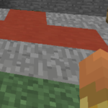  First person perspective | 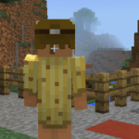  Third person, back view | 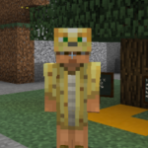  Third person, front view

Changing settings
If these keyboard settings are non-intuitive, you can change them. You can also see how to move around with a controller, a touch interface, or modify any or all of these settings:
Press ESC to return to the menu.
Select Settings
Scroll down to Controls and click on the desired interface.
Modify as needed – if you make a mistake or want to go back, you can find the reset button to change everything back at the bottom of the list.
No need to save, the settings are updated automatically. Find out what works best for you!
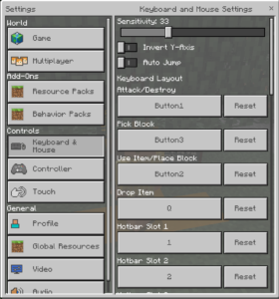 | 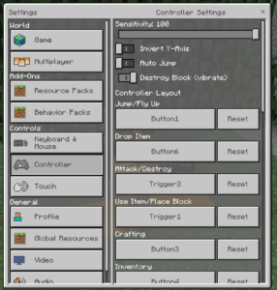 | 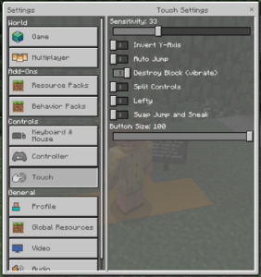

Using Classroom Mode (Teacher Only)
*All versions of Minecraft Edu programs must be up-to-date for this to work. (v. 1.0.21)*
Classroom Mode is the student management system for Minecraft. It holds up to 30 players.

Connecting Minecraft Edu and Classroom Mode
Find and start Minecraft Edu
Check the settings on a world and open it

Press T (means Type)
Type /classroommode and press Enter
Allow Classroom Mode for Minecraft to start up
Sign in to Classroom Mode with your Roanoke County Username (whole email address) and Password

Copy the code on the screen (you may have to click Waiting Room first)
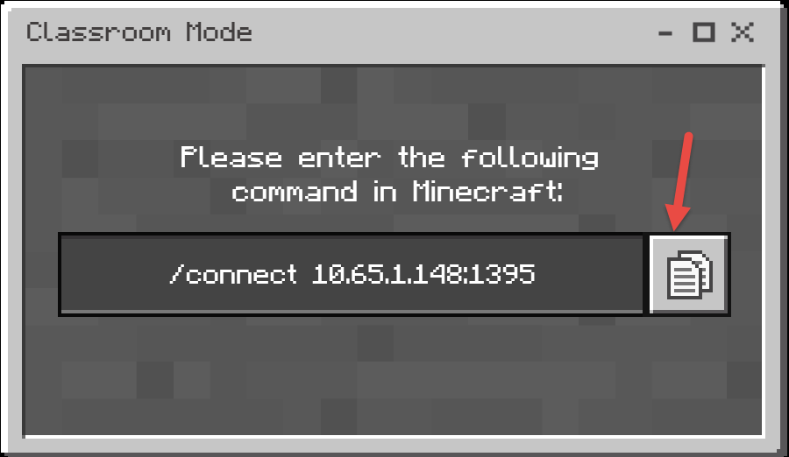
Paste the address in Minecraft Edu

Now the two programs (Minecraft Edu and Classroom Mode) should be connected and running together. You should be able to control the game from Classroom Mode.

To Add Students

Press the Esc key
Provide the IP address to the students. They will add this as a server and join the game.

